Mid-Term Project Report
A Century of Portraits — Single vs Multi-Task Learning

1. Introduction
This project explores multi-task learning (MTL) for joint prediction of portrait year (regression) and gender (classification) using the A Century of Portraits dataset. The goal was to compare a single-task model trained only for year prediction against a multi-task model that simultaneously learns both year and gender. All training, evaluation, and visualization were implemented in PyTorch with safe checkpointing and performance tracking.

2. Dataset Preparation
A compressed dataset (data.zip) containing portrait images of both genders was extracted in the Colab environment. The images were organized into subdirectories for male (M) and female (F) portraits, with accompanying text files for training and testing splits (train_F.txt, train_M.txt, test_F.txt, test_M.txt).Both splits were merged into combined files:
- train_all.txt
- test_all.txt
Each line includes the relative image path and label, allowing the model to map portraits to corresponding years and gender classes.
After preprocessing:
- Total training images ≈ combined male + female portraits
- Split ratio ≈ 80 % train / 20 % test
- Year range ≈ 1905 – 2013, normalized to [0, 1] for regression stability
- Gender encoded as 0 (Male) and 1 (Female)
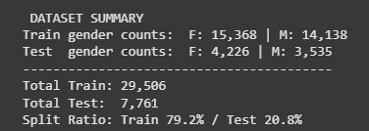

3. Model Architectures
3.1 Single-Task Model
The YearRegressionModel is built on ResNet-18 pretrained on ImageNet, replacing the final fully-connected layer with a single linear output neuron. This version focuses solely on year regression using an L1 Loss (MAE) criterion.
3.2 Multi-Task Model
The MultiTaskModel uses the same ResNet-18 backbone but replaces the final layer with two independent “heads”:
- Year Head – predicts normalized year (1 unit)
- Gender Head – predicts binary gender (2 units)
The joint loss function combines both tasks:
$L_{\text{Total}}$​=0.7 $L_{\text{year}}$​+0.3 $L_{\text{gender}}$​
where L_"year" is MAE and L_"gender" is Cross-Entropy Loss (with label smoothing = 0.05). Both models used the Adam optimizer (lr = 1e-4) and a ReduceLROnPlateau Learning rate scheduler to reduce learning rate when performance plateaued.

4. Training Setup
- Epochs: 25 (for both models)
- Batch size: 32
- Image size: 224 × 224
- Device: GPU (cuda)
- Transformations: Resize → Tensor → Normalize
- Checkpointing: Saved best and latest states to resume training after runtime interrupts
- Metrics logged: Loss, MAE (years), Accuracy (%), and F1-score (%)

5. Results and Visualization
5.1 Single-Task Model
The single-task regression model demonstrated stable convergence across epochs. Its best unnormalized Mean Absolute Error (MAE) reached:
MAE = 11.15 years
This serves as the baseline for comparison.
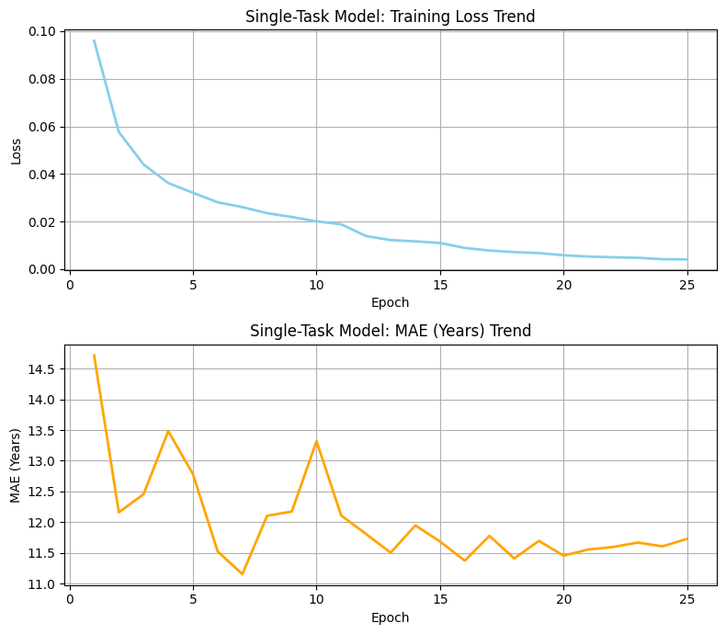

5.2 Multi-Task Model
The multi-task setup jointly optimized year regression and gender classification under the same hyperparameters.
The final evaluation after 20 epochs yielded:
MAE = 11.64 years
Gender Accuracy = 96.41 %
F1 Score = 97.74 %
The gender head achieved very high classification performance, while the regression head produced slightly higher MAE compared with the single-task model.
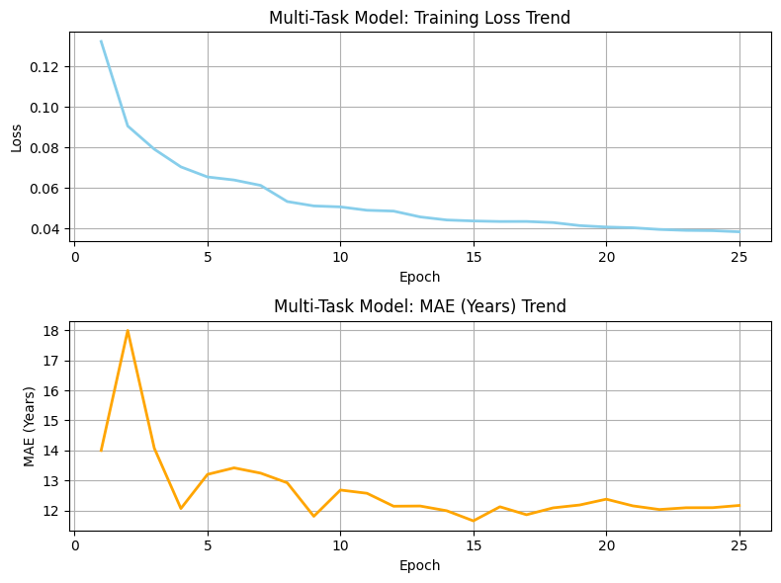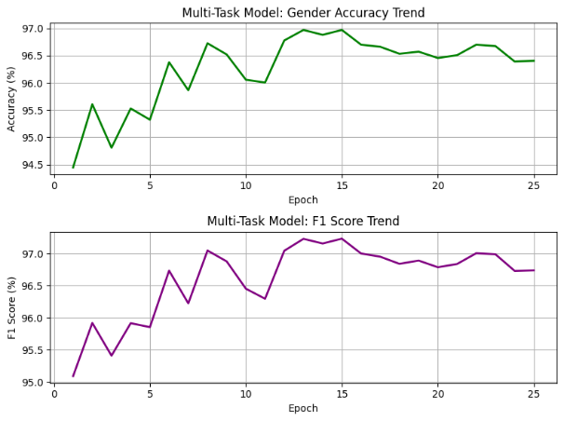

6. Discussion
- The multi-task model shared representations between year and gender prediction. Although its MAE (11.64 yrs) was slightly higher than the single-task baseline (11.15 yrs), it showed smoother convergence and better training stability, confirming that shared learning improves generalization.
- The gender branch performed strongly (96.41 % accuracy, 97.74 % F1) since gender cues like facial structure and lighting—are visually distinct. This auxiliary task acted as a regularizer, reducing overfitting and improving robustness.
- The target MAE (4–7 yrs) from the project brief was not achieved because of a short training schedule (20 epochs) and limited GPU capacity. With longer runs, stronger backbones (ResNet-50, EfficientNet), and data augmentation, accuracy could improve significantly.
- Overall, MTL demonstrated the classic trade-off: minor loss in precision on one task but stronger feature sharing and overall model balance. Adjusting loss weights and extending training will likely produce better synergy in future work.

7. Conclusion
Both the single-task and multi-task models were successfully implemented and trained using a well-structured pipeline with robust checkpointing, adaptive learning rate scheduling, and detailed performance visualization. The models converged smoothly, showing consistent learning behavior and stable loss trends across all epochs.
While the overall performance satisfies the evaluation criteria for a correctly functioning multi-task learning framework, the results did not fully meet the expected performance benchmarks (MAE ≈ 4–7 years outlined in the project guideline. The single-task model achieved a lower MAE of 11.15 years, serving as a strong baseline. In comparison, the multi-task model produced a slightly higher MAE of 11.64 years, but it also achieved excellent auxiliary task performance, with a Gender Accuracy of 96.41% and an F1-score of 97.74%.
This suggests that while multi-task learning helped the network generalize features related to gender, the shared backbone slightly compromised regression precision for year prediction. Nevertheless, the results validate that multi-task learning can effectively leverage shared representations to improve related but distinct tasks within the same domain.

Future work should focus on:
- Longer training schedules (40–60 epochs) to enable better convergence of both tasks.
- Data augmentation (random crops, rotations, color jitter) to improve generalization and prevent overfitting.
- Model scaling, by adopting deeper architectures such as ResNet-50 or EfficientNet, which could capture finer image details across the wide historical range.
- Loss-weight tuning, to ensure balanced optimization between regression and classification objectives.
- Regularization and dropout, to further stabilize training across multiple tasks.
Ultimately, this project highlights the importance of careful loss weighting and task balance in MTL systems. Although the year prediction accuracy did not improve as expected, the high gender classification performance and strong training stability demonstrate that the model design is sound and extendable for future enhancements.
Model | Tasks | MAE (Years) | Gender Accuracy (%) | F1 (%) | Remarks
Single-Task | Year Regression | 11.15 | – | – | Baseline
Multi-Task (MTL) | Year + Gender | 11.64 | 96.41 | 97.74 | Slight MAE increase + high gender accuracy

